Retrouvaille Saskatchewan
Retrouvaille is an international community of disciples committed to the continued healing of their own marriages. Empowered by the Holy Spirit, couples from the community share their stories, talents and gifts to promote and spread the healing ministry of Retrouvaille to other hurting couples.
Retrouvaille was started in Canada in 1977, in the province of Quebec. The program is Catholic in origin, ecumenical and Christian in orientation and welcomes married couples of other faiths. In 2007, Retrouvaille held its inaugural weekend in Saskatoon, and since then, weekends have been offered in Saskatoon in September and April.
Retrouvaille means Rediscovery. This program is designed for couples who have lost their way, couples who are considering counselling, separation and divorce, or who may be already separated or divorced but are considering reconciliation. It operates from a premise of hope and the belief that if you and your spouse want your marriage to endure and are willing to put in your best effort, renewal in the relationship can be achieved.
During a Retrouvaille weekend, couples learn that there are four stages in marriage: romance, disillusionment, misery, and the time of awakening. They are also introduced to the four cornerstones of marriage: love as a decision, commitment as a decision, and trust and forgiveness as decisions, and how to communicate with one another and share feelings in a positive and respectful way. During the post sessions these decisions and other communication techniques, including conflict management that promote health and intimacy in the marriage relationship are explored in more depth.
The Retrouvaille program has received the Smart Marriages Impact Award. The award recognizes Retrouvaille as a “program that never gives up and proves time and again that there is no such thing as a hopeless case.” At the Retrouvaille International Conference in Rome in 2008, Pope Benedict met with delegates from 17 countries. His Holiness referred to Retrouvaille servants as “Custodians of a bigger hope for couples who have lost it”, and the “Guardians of Hope”.
What Couples have said:
Couples who have attended Retrouvaille weekends in Saskatchewan frequently report coming to change and leaving the experience with the road map to restore intimacy, and their commitment to the marriage restored.
Others have said:
- A highly important, necessary experience to a long term rewarding marriage.
- Listening to the stories of the speakers helped us realise that we have experienced the same hurt and that we’re not alone.
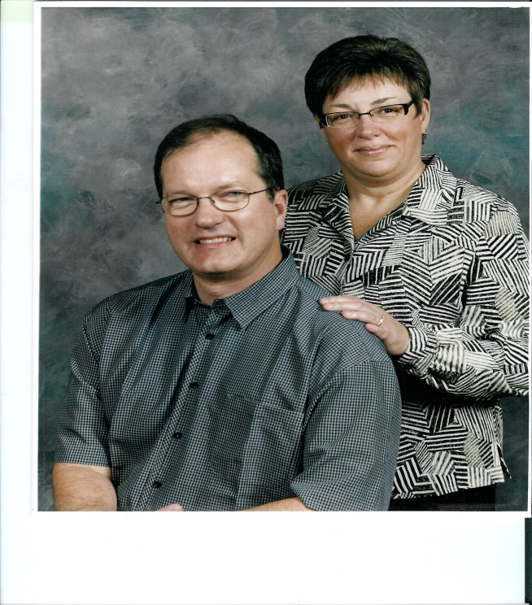
Mike and Celia attended first Retrouvaille weekend in September 2007 and continue to be involved with Retrouvaille Saskatchewan ever since. In May 2013 we were elected the Community Coordinators for Retrouvaille Saskatchewan.

Celia and Mike share their weekend experience to encourage others to attend:
Celia states “Before coming to the weekend I(Celia) felt betrayed like all my hopes and dreams for a happy marriage were destroyed and irreparable. As I settled into the Retrouvaille weekend I started to feel a glimmer of hope that Mike and I could grow and I could emerge from my despair. This glimmer of hope was like seeing a pin prick of light at the end of a dark tunnel. Two weeks after our weekend we attended our first post session. During that session we were asked to share about our weekend experience. I described feeling like a plant that had been deprived of water that was finally starting to sprout some new shoots. As Mike and I stopped arguing and started to talk with each other and share feelings, I felt encouraged and renewed like I was moving out of the cold of winter into the newness of spring.”
Mike remembers, “Most of my career has kept me from my family and from Celia. In my misery heated arguments seemed to occur daily. It was no wonder our relationship was in trouble. I felt angry and alone and took my anger out on those closest to me that being Celia and our children. Retrouvaille gave me the opportunity to focus totally on our relationship and the tools to communicate and express my love for Celia more effectively. It also gave me information on conflict resolution, and hope that we could change and restore intimacy. It has been invigorating for me, like going through the cold dark damp of night and then seeing the sunrise and feeling of warmth and hope that comes with a new spring day.”
Retrouvaille has over 200 support communities worldwide. Retrouvaille Saskatchewan serves any married couple who wishes to attend the Saskatchewan program.
Retrouvaille is a ministry of hope – hope that marriages can survive indifference, anger, despair, emotional distance, adultery, selfishness, alcoholism, or other addictions and be reawakened to intimacy.
Retrouvaille is an opportunity to rediscover each other and to renew the intimacy in your marriage.
For more information or to register call (306)-652-7155 or email retrouvaille@sasktel.net.
For more information search website www.retrouvaille.org or www.helpourmarriage.com

