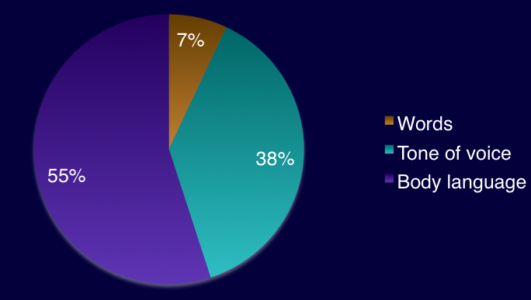  There is a lot more to it than words.  What to Avoid.  - Women should avoid the “little girl” voice. Lower tones carry more authority.  - Avoid the Valley Voice. That is making a statement sounds like a question.  - Avoid soft voices unless you are using it to control a difficult meeting or handle conflict.  - Forgetting that the tone of your voice is part of your verbal message.  - Avoid ‘uhs’ and ‘ums’ as fillers. This can be a very distracting. Instead of using these terms, pause.  - Avoid using ‘you know’ and ‘like’ as fillers  - Avoid using ‘you guys’.  - Practice, it is a valuable tool.  - Avoid mumbling.
  Remember:
  - Before you answer the phone—smile.
  - Find a ‘voice model’ you like and practice it.
  - Enunciate clearly, avoid mumbling.
  - Avoids ‘uh’, ‘like’ or ‘you know’—just pause.
  - If you want to change your speech patterns, ask for feedback.
  Contact Us
  Phone: 306-352-1651
  Email: lburkhart@archregina.sk.ca or
  sbender@archregina.sk.ca
  Web: www.archregina.sk.ca
  Address:
  Archdiocese of Regina
  200 – 2151 Scarth Street,
  PO Box 1546 Stn. Main.
  Regina, SK S4P 3C4
   |  | Tone of voice matters  
  
  Tone of voice matters
    - Prepared by the Parish Pastoral Support Services Department, Archdiocese of Regina.

  Tone: It Matters  Your tone of voice can change the meaning of what you are saying. The tone of your voice can convey a stronger meaning than the words themselves. Voices can be used to engage people in a kinder and more attractive way. Voice is a powerful tool.  Use it wisely and effectively!  Tone is defined as a quality or character of sounds. It is the modulation or intonation of the voice as expressive of some meaning, feeling, or spirit.  Remember: Tone of voice is open to interpretation. |  |  | Inflection and Volume  - Inflection is part of the nuance of meaning.  - Inflection is the way many people put meaning into a conversation beyond words.  - Volume that is too loud may make someone feel they are being yelled at or being bullied.  - A voice that is too quiet and soft, can make it difficult for people to hear you.  - A voice that is too soft may convey that you lack confidence.  - A voice that is “too tight” can indicate that something is wrong or show fear.  - Anger and fear can also be displayed in your tone.  Pronunciation  - Pronounce your words correctly. Poor pronouncing can be interpreted as lack of experience, education or sophistication.  - Pay attention to pronouncing names correctly. Some people are offended by the mispronunciation of their name.  - Continually mispronouncing some one’s name may be considered rude and disrespectful.  “Don’t be shy! Show them how fabulous you are! This is a great spot for a glowing testimonial.”  Get the exact results you want  To easily customize the look of this brochure, on the Design tab of the ribbon, check out the Themes, Colors, and Fonts galleries.  Have company-branded colors or fonts?  No problem! The Themes, Colors, and Fonts galleries give you the option to add your own. |  |  |   How is he/she feeling?  Smiling  - Sound as if you are engaged and interested.  - Trying smiling before you enter a conversation or answer the phone.  - A smiling person is perceived positively. They are looked upon as friendly and confident.  - Plan the first and last words of a conversation. Plan to discuss something pleasant at the beginning and at the end of a discussion.  Pauses  - Speak energetically but not too fast.  - Use pauses to control your speed.  - Pause at key times to add power to your conversations.  - If you want to emphasize a point or be more dramatic, pause.  - Listen to great speakers to learn examples of how to pause effectively.

