**Join us in celebrating the 70th**

* **Kaposvar Pilgrimage** 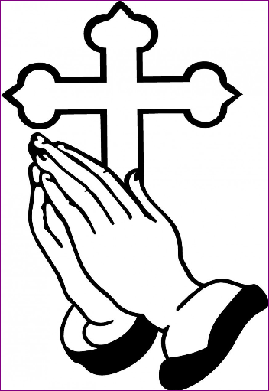

**Our Lady of Lourdes Shrine**

**Sunday August 18, 2024**

**3 miles South & ½ mile West of Esterhazy on Grid 637**

**Souvenir Shop opens at 11:00**

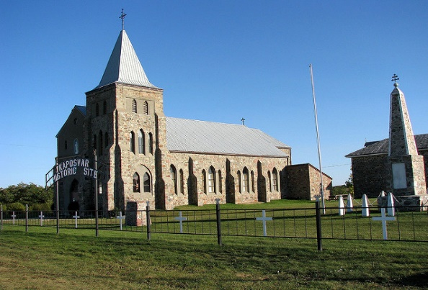 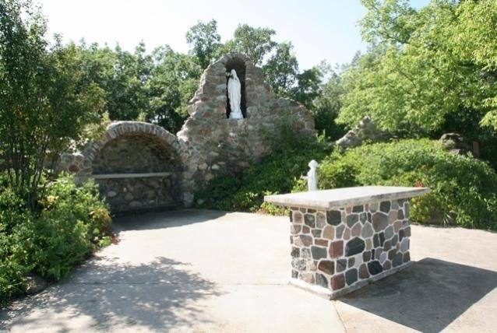

|  |  |
| --- | --- |
| 11:00 am – 12:00 noon….. | Visitors arrive and sign guest book |
| 12:00 noon – 1:00 pm…… | Individual Stations of the Cross |
| 1:00 pm – 2:00 pm……….. | Rosary in the Church |
| 2:00 pm – 2:45 pm……….. | Private Confessions in the Church |
| 2:45 pm – 3:00 pm……….. | Procession from the Church to the Shrine |
| 3:00 pm – 4:00 pm……….. | Holy Mass & Anointing of the Sick |
| 4:00 pm………………………… | Procession back to the Church |
| 4:15 pm………………………... | Supper |
|  |  |

For more information Contact:

Eola Stevenson @ 306-853-7880

Rhonda Bogden @ 306-527-3438

Email: Kaposvarhistoricsite@gmail.com