**Celebrating**

***the Feast Day of St. Martin de Porres***

***with a* Harvest Supper**

**Sunday, November 2, 2025**

**at**

**St. Martin de Porres Parish** **Hall**

**4720 Castle Road, Regina**

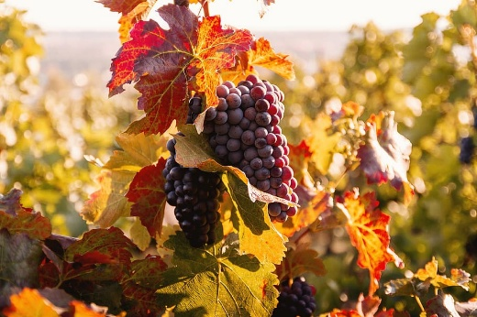**4:00 p.m. Wine/Beer Cash Bar**

**5:00 p.m. –Turkey Supper**

**Turkey, mashed potatoes, gravy, vegetable, 7 salads, plus dessert**

***Catering by Charlotte’s Catering***

**Tickets:**

**$35.00 per adult, $10.00 ages 3 to 10, 2 & under free**

**Purchase tickets by Wed., Oct. 22**

**E-transfer: st.martinsadmin@sasktel.net**

**or by cash/check at St. Martin’s parish office.**

***Please note: no refunds after Oct. 22nd.***