CHRISTMAS BAKING TRAYS
Proceeds go to the Cuernavaca Project
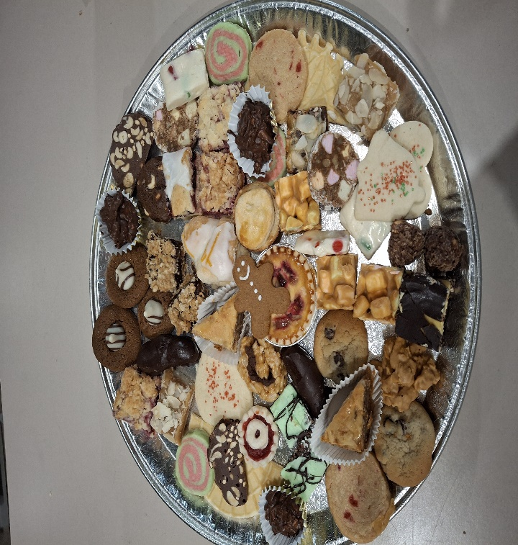
We are selling individual trays of Christmas baking with an assortment of dainties consisting of cookies, squares, and tarts. 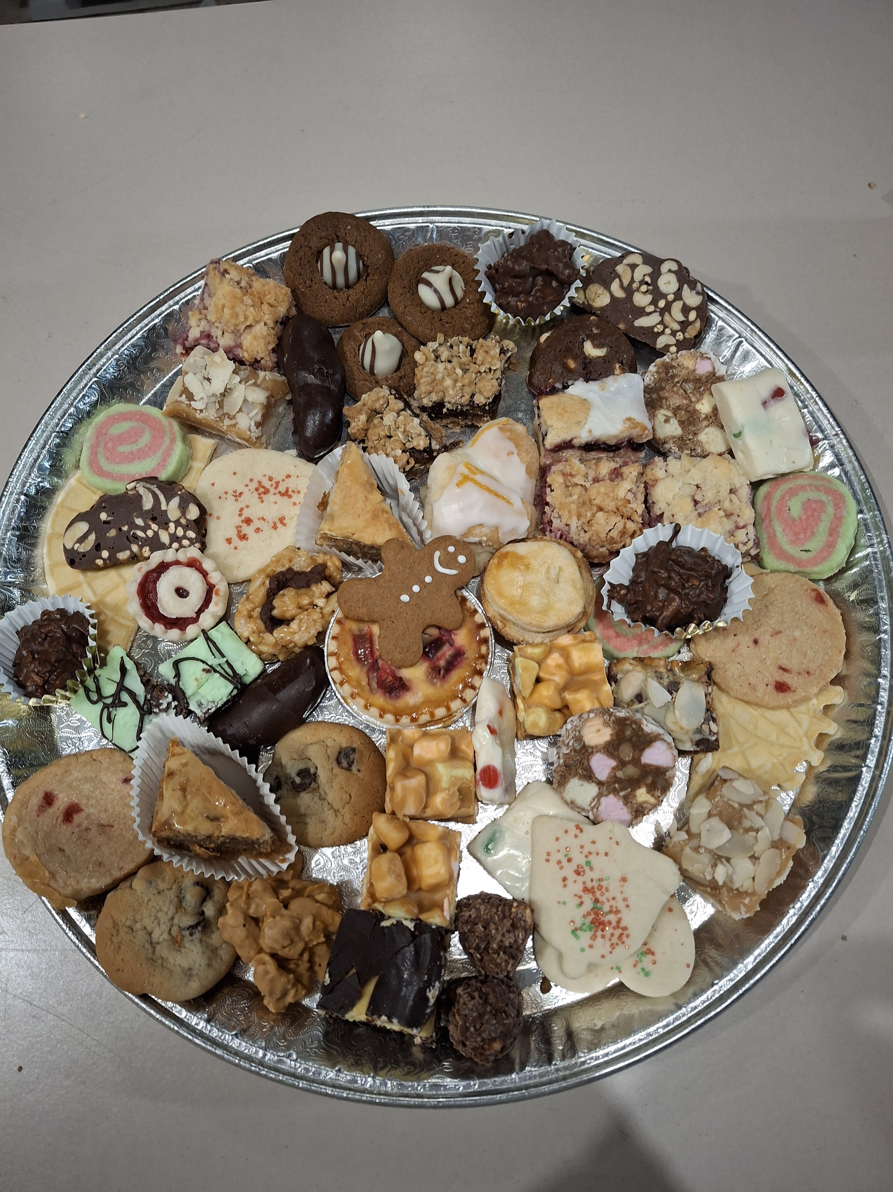
$40 tray (approx. 36-40 pcs) $25 tray (approx. 24-26 pcs)
To order call:

Debbie @ 306-533-2118 or Joan @ 306-533-1648
debbiebulych@gmail.com jmrink@sasktel.net

Deadline to place orders for baking trays is November 26, 2025
Tray pick-up is to be worked out with Debbie

