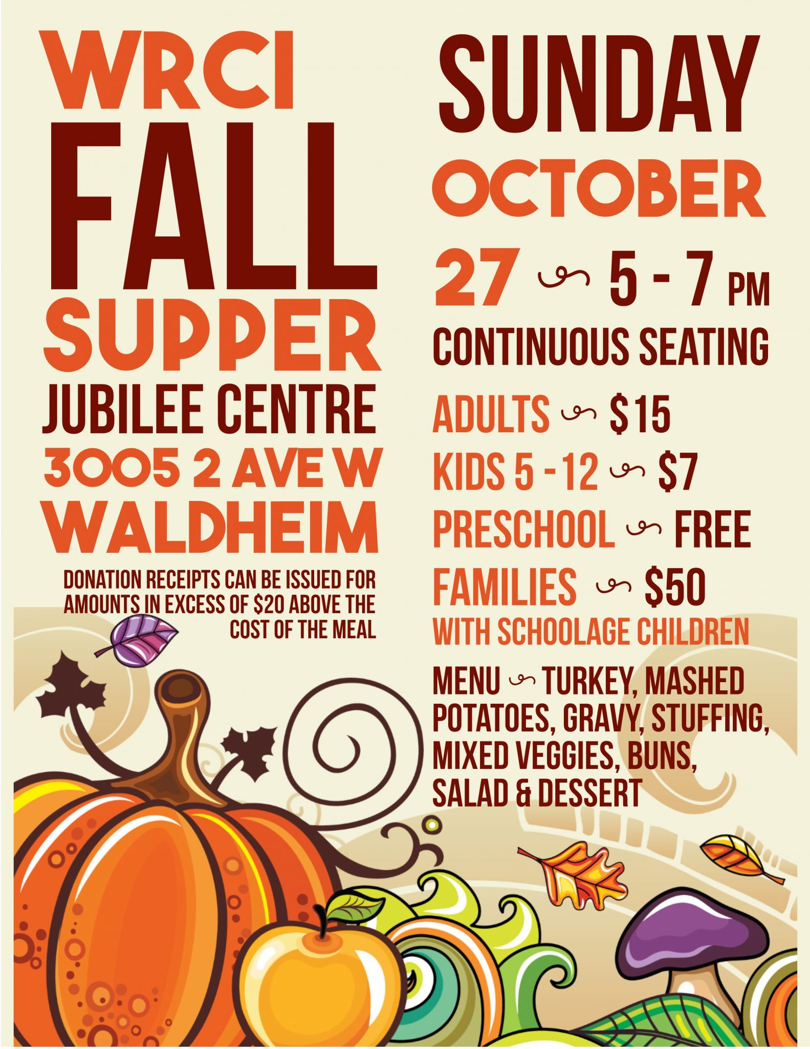
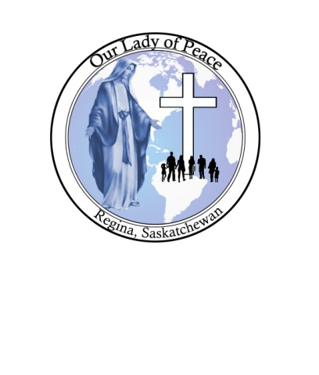 Our Lady of Peace Church
425 Broad St N
Turkey … Potatoes, gravy, hot vegs, stuffing, selection of salads, cranberry sauce, buns, dessert & refreshments

Our Lady of Peace Church
425 Broad North
Regina
Fri, Oct. 09
5:30 to 6:30 p.m.
Catered by Charlotte’s
295
15
Tickets: Call Anita at 306 543-0421
Or: Call or Text Dennis at 306-530-2370
e-transfer available ourladyofpeace@sasktel.net

Annual

Tables reserved for groups of 6 or more
ENJOY Supper .. Door Prizes ... 50/50 ...Raffle Tickets
Will deliver orders of 10 or more meals.
Sponsored by Our Lady of Peace Finance Council and all Proceeds from this Fundraiser go towards Mortgage Payments

