Stewardship Bulletin Bits
September 13, 2026 24th Sunday in Ordinary Time
“For if we live, we live for the Lord, and if we die, we die for the Lord; so then, whether we live or die, we are the Lord’s.” – Romans 14:8
This is the essence of stewardship – everything we have and everything we are is a gift from God. We aren’t “owners” of anything, we are merely “stewards” of the gifts that God has given us, especially our very own lives. Pray to God, daily, and ask Him how He is calling you to the live the life that He intended for you.

Season of Creation 2026 September 1 to October 4
The Season of Creation 2026 invites us to do something essential: to pause, reflect, and understand 🌍
We have prepared a document that explores the meaning of this year’s theme, Living Water—a guide to connecting faith with action and responding to the call of our Common Home.
📖 Read it, let it challenge you, and discover how to be part of the change.
Because all transformation begins when we understand and decide to act. 💚
Link: https://bit.ly/SOC226
#SeasonOfCreation2026

Pope’s Prayer Intentions: September
For the Care of Water
Let us pray for a just and sustainable management of water, a vital resource, so that everyone may have equal access to it. https://www.popesprayer.va/praywiththepope/

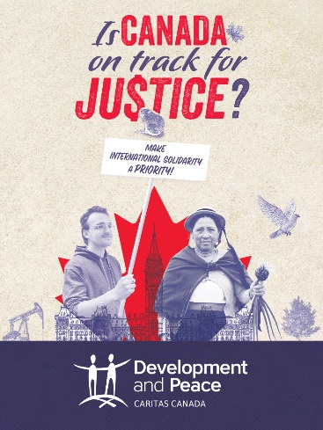
Is Canada on Track for Justice?
This fall, Development and Peace — Caritas Canada (DPCC) encourages you to take part in its Is Canada on Track for Justice campaign to call on the Government of Canada to increase funding for official development assistance at a time when the world is facing multiple crises and aid for impoverished countries is becoming increasingly scarce.
Together, let’s make international solidarity a priority through three simple actions:
- Become a member of DPCC;
- Meet your MP;
- Organize an awareness-raising event in your community.
To learn more, visit devp.org/campaign.

Seeding an Economy of Life: Emerging Ideas for a Just Climate Transition for All in Saskatchewan
Join KAIROS Regina and partners for a day of imagination, creativity, and conversation. Explore practical, hope-filled tools for building a just transition beyond fossil fuel dependence. Lunch included. Free; donations welcome. September 19, 10am-4pm. Christ the King Parish, 3239 Garnet St, Regina and online. Register here: https://secure.kairoscanada.org/civicrm/event/register?id=456

Walking Together- a program of Catholic Engaged Encounter designed to support MARRIED COUPLES in their vocation of marriage through accompaniment. Open to couples of all stages, from newly married to those celebrating decades of marriage. Each evening includes a themed presentation, dedicated time for couples to reflect and share privately, and an opportunity for group sharing.
Drop-in sessions, no registration required. Saturdays at 7:30 pm at Holy Rosary in the O’Neill room (use the west ramp entrance) September 26, October 17, November 21, December 19, January 23. For more information contact Miri or James Schiller at wd1@ceecanada.ca or 306-535-7518.

Called to Serve – Catholic Health Association of Saskatchewan (CHAS)
The Catholic Health Association of Saskatchewan (CHAS) invites applications for its Board of Directors. Guided by our vision of a Catholic community empowered to continue Christ’s healing ministry, CHAS is currently focused on strengthening palliative care and building stronger bridges between Catholic health care and our dioceses.
We are seeking individuals with expertise in Board Governance, Financial Management, Catholic Health Care, Ethics, or Advocacy. Facilitating board participation from all the dioceses in Saskatchewan is a priority that is supported by virtual meeting options.
To learn more or submit an application, please visit chassk.ca or contact Peter Oliver, Executive Director at peter@chassk.ca or 306-955-2427. Deadline: September 23, 2026.

ANNUAL FALL SUPPER
Our Lady of Peace on Friday, Oct. 9, 5:30 to 6:30 p.m., Turkey supper catered by Charlotte’s Catering. Tables will be reserved for groups of 6 or more. Orders will be delivered of 10 or more meals. Tickets: Adults $29.00, youth 5 to 12 $15.00 and preschool FREE. Call Anita at 543-0421 or text 526-5130, or call or text Dennis at 530-2370, with e-transfer available to ourladyofpeace@sasktel.net.

