Stewardship Bulletin Bits
September 20, 2026 25th Sunday in Ordinary Time
“Thus, the last will be first, and the first will be last”. – Matthew 20:16
You’ve heard the saying “it’s not where you start, but how you finish.” This certainly applies to this Bible passage. We have a responsibility not only for our own lives, but for the lives of others as well. We are called to generously share our gifts with others, not hoard them for our own use. Our sincere gratitude and cheerful generosity will help us live “God-centered” lives and not “self-centered” lives.

Season of Creation 2026: September 1 to October 4
Water is the source of life, a gift from God and a right for all creation.
✨ Discover in the 2026 celebration guide how you can tackle water pollution, because we are called not only to avoid polluting, but also to speak out against actions that harm rivers, seas, lakes and sources of life. 🌎
Now available here 👉https://seasonofcreation.org/resources/
#LaudatoSi #CareForWater #CommonHome

MyGen Visioning Meeting
The Office of Youth and Young Adult Ministry of the Archdiocese of Regina invites anyone interested to join us for a night of visioning for the My Gen Youth Rally. My Gen is now 15 years old, and we recognize that it could benefit from some newness and freshness. Come brainstorm with us and share ideas with the My Gen Planning Committee!
Wednesday, October 7, 2026
6:30 PM
Archdiocese of Regina Office
200 - 2151 Scarth Street

An online event to add to your calendar!
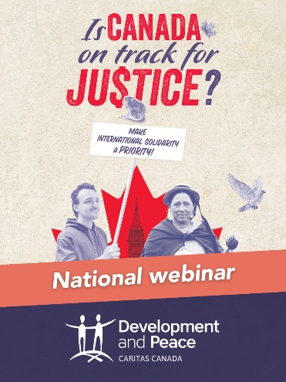
Don’t miss the national launch webinar hosted by Development and Peace — Caritas Canada (DPCC) to promote the mobilization campaign Is Canada on Track for Justice? Join us on Saturday, September 26, at 11:30 AM CST to discuss the impact of cuts to official development assistance and how to take action here in Canada:
- Bishop Martin Laliberté, member of the DPCC National Council;
- Wesley Chibamba, Advocacy Officer at Caritas Africa;
- Dean Dettloff, Advocacy and Research Officer at DPCC;
- Lea Mannari, Youth Programming Officer at DPCC.
To learn more and register, visit devp.org/events.

Christian Centering Prayer
Christian Centering Prayer or Christ-Centred meditation is a silent prayer of simply resting in God. A Centering Prayer Introductory Workshop will be held at Christ the King Parish on Saturday October 17, 2026, from 10am to 3pm. There is a suggested donation of $25; Lunch will be provided.
For more information about Centering Prayer or to register for the Introductory Workshop please contact Judy Corkery at her email: judithcorkery@gmail.com or phone: 306-543-2914. https://archregina.sk.ca/grouppage/centering-prayer-in-regina/

Do Canadian Christians read and engage the Bible?
You are invited to join a briefing session with the Canadian Bible Society on a recent survey of reading the Bible in Canada. Do NextGen really read the Bible? What is the impact of social media and digital apps on the thoughtful and faithful engagement with the Scriptures?
Wednesday, September 23 at 7pm
Argyle Baptist Church, 3514 Argyle Rd, Regina
We will explore some of the results of a recent survey for the Canadian Bible Society by Cardus and the Angus Reid Institute on how Canadians engage with and understand sacred texts. How do Canadian Christians read the Bible? Why do they read the Bible? What do they think about the Bible? Do they know the Bible? The survey reveals significant differences among Christians in how, when, and why they read the Bible.
Presenter Tim Schulz is Canadian Bible Society Regional Director for the Prairies and Northwest Territories. Established in 1906, the Canadian Bible Society works with translators and publishers in 240 countries to promote Bible reading and provide Bibles in the heart language of all Canadians.
No registration required. All are welcome
For further details, contact Nick Jesson, jesson@ecumenism.net

Holy Family Fall Supper
Fall Supper in support of the Holy Family Parish Refugee Sponsorship Committee
Mark your calendars! Join us for a delicious Fall Supper on Saturday, October 3, from 6:00 to 8:00 p.m. Enjoy a classic turkey dinner with all the traditional fixings catered by Charlotte’s Catering.
Ticket Prices:
- Adults: $30
- Youth (Ages 7–12): $15
- Children (6 & under): Free!
Tickets go on sale starting September 5. Payment by cash, cheque or e-transfer to finance@holyfamilyregina.com. (Note your name and purpose in the memo).
Don't miss out on great food for a great cause—plus, we'll be hosting a 50/50 raffle during the evening! We hope to see you there. For more information, contact Patty at 306-535-8251 or patty.gianoli@gmail.com or Donna at 306-535-3618. Don't wing it —grab your tickets before they're gone!

Holy Cross Parish Harvest Supper
Provided by Charlotte’s Catering
Turkey, salads and all the trimmings
Sunday, October 18
Reserved seating for 5:00 pm setting
Resurrection Parish Hall, 3155 Windsor Park Road
$30 Adult $12 Youth (6-12) Free—Child (under 6)
50/50 draw and Cash bar
Payment by: Cash or cheque (made out to Holy Cross Parish)
e-Transfer to bookkeeper.holycross@sasktel.net with your name and telephone number
(NOTE state number of guests for each order, at each group level & who you wish to sit with)
Order deadline Tuesday Oct. 13 at noon.
Call Wayne 306-789-8151 or Pat 306-533-4180

Rachel’s Vineyard
Are you hurting because of an abortion? Rachel's Vineyard is a safe place to renew, rebuild and redeem hearts broken by abortion. Weekend retreats offer you a supportive, confidential and non-judgmental environment where women and men can express, release and reconcile painful post-abortive emotions to begin the process of restoration, renewal and healing.
Our next retreat in Saskatchewan will be held on October 2-4, 2026
To register, please contact Elaine at 1-306-480-8911
or email r.vineyardsk@sasktel.net

