Please Support
Visitation House

Sponsor the

"Holey Soles" Relay Team

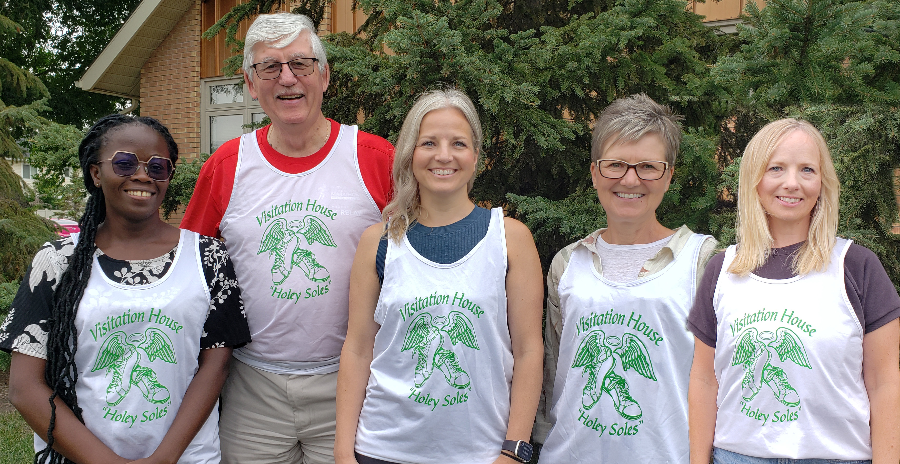in the Queen City Marathon
Cybelle, Fr. John, Renee, Loralie, Shelan

Donations of $10 or more receive a charitable donation receipt.

Donations coordinated through the CWL.

Cheques payable to Visitation House.

