Stewardship Bulletin Bits
October 18, 2026
29th Sunday in Ordinary Time
“Render therefore to Caesar the things that are Caesar’s and to God the things that are God’s. – Matthew 22:21
Everything we are and everything we have belongs to God. We aren’t “owners” of anything; we are merely “stewards” of the gifts God has given each of us. All God is asking is that we give back a portion of what He gave us. This is the essence of Stewardship. God should be our first priority in everything. All else comes second, especially our money.

ArchRegina Congress: Blessings Remembered, Hope Renewed
What might God be inviting our parish communities to become, and where do we begin?
Join us for our annual Archdiocese of Regina Congress on October 31 at Resurrection Parish from 10:00 AM – 3:00 PM (with an optional Mass at 9:00 AM).
Keynote Guest Speaker: Sr. Nathalie Becquart - Undersecretary of the General Secretariat of the Synod of Bishops (via Zoom)
Together we’ll continue to explore God’s vision for the Church and consider what that vision might look like in our parishes. Through prayer, communal discernment, and creative activities, we’ll reflect on our blessings, name our challenges, and share our hopes and ideas for the future. Together, we’ll identify practical, pastoral next steps for our parishes and our diocese and set a path forward as we prepare for our Archdiocesan Synod Assembly in May 2027.
Please register by Monday, October 26, to mgurash@archregina.sk.ca or call 306-352-1651.

Archbishop’s Appeal October 18
Bulletin Reflection
1st Reading: Isaiah 45:1, 4-6; 2nd Reading: 1 Thessalonians 1:1-5b; Gospel: Matthew 22:15-21
In today's Gospel, Jesus reminds us to "give to Caesar what belongs to Caesar and to God what belongs to God." It is a simple yet powerful reminder that our lives, our gifts, and our blessings ultimately belong to God. We are called to honour Him not only with our words, but also through the way we live, serve, and care for others.
St. Paul also gives thanks for the faith, hope, and love of the Christian community—qualities that continue to strengthen the Church today. Every act of generosity, whether through our time, talents, or financial support, helps reflect God's love in the world.
As we continue the Archbishop's Appeal, may we prayerfully consider how each of us can share the gifts God has entrusted to us, helping to build a stronger and more compassionate Church for all.
Prayer of Intercession
For each of us, that our faith may be seen in the way we treat others, share our blessings, and bear witness to Christ in our families, workplaces, and communities. We pray to the Lord.

Thank you from Fr. John Weckend
I would like to thank the Regina parishes for again generously supporting the relay team running for Visitation House in this year’s Queen City Marathon. In particular I wish to thank all the team runners who have participated over the years as well as all the CWL ladies for collecting the donations. It has been an honour for me to have supported Visitation House over these past 25 years. But time marches on and it’s time to hang up the running 👟 shoes. May we continue to support the wonderful work which Theresa Hilbig and her volunteers do in any way we can. Again, thank you and may God bless you! Fr. John Weckend
October 17
Another successful season sowing solidarity!
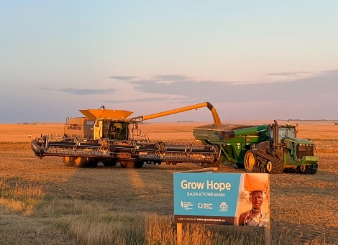
The Harvest is IN. Did you know that GROW HOPE SASKATCHEWAN, an ecumenical initiative of the Canadian Foodgrains Bank, is wrapping up its 9th season of growing crops to fight hunger around the world? Generous farming families in Saskatchewan have pledged 505 acres this year, but they need your help to maximize their yield! Generous donors match this contribution by covering input costs for those acres (fuel, fertilizer, etc.) valued at $350 an acre. The deadline to support the 2026 growing season is October 31. To give visit www.growhopesk.ca/donate and locate “Development and Peace” in the list of agencies.

