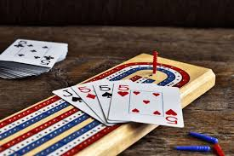
Join us for an afternoon of cribbage – Sponsored by the 55+ group

Our Lady of Peace Parish
425 Broad Street North

Friday, October 30, 2026
1:00 pm to 3:30 pm
Doors open 12:15 pm Cost - $8.00 person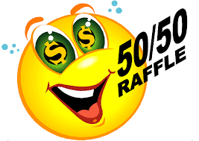
7 games will be played
Payouts on 1st, 2nd and 3rd place
Change partners every round

For more information or to pre-register please contact Erna at 1-306-221-1567
Refreshments and dainties included

Please use north entrance

Payouts on the 1st four playable 24 hands
Payout on a playable 29 cribbage hand

Thank you for your continued support!!

